**BUS RESERVATION SYSTEM**

**EXPERIMENT-2**

**ANALYSE REPORT OF PROJECT**

**Abstract of project**

The Bus reservation system is a software engineering project aimed at providing an efficient solution for tracking and locating buses in real-time. This system addresses the need for improved public transportation management by offering passengers a convenient way to track bus locations and estimated arrival times. The project involves the development of a web or mobile application with features tailored for passengers, bus operators, and administrators.

Key functionalities of the Bus reservation system include:

1. Real-time bus reservation: Passengers can view the current location of buses on a map and reserve their seat .
2. Route information: Users can access detailed information about bus routes, stops, and schedules to plan their journeys effectively.
3. Estimated arrival times: The system provides passengers with estimated arrival times based on bus locations and historical data, enhancing the commuting experience.
4. Administrator dashboard: Bus operators and administrators have access to a dashboard for managing bus routes, schedules, and monitoring system performance.
5. Alerts and notifications: Passengers receive alerts and notifications regarding delays, route changes, or other relevant information to stay informed about their travel plans.
6. The development process follows software engineering principles, including requirements gathering, system design, implementation, testing, deployment, and maintenance. By leveraging technologies such as GPS tracking, database management systems, and web/mobile application frameworks, the Bus reservation system aims to improve the efficiency and reliability of public transportation services while enhancing the overall user experience for passengers.

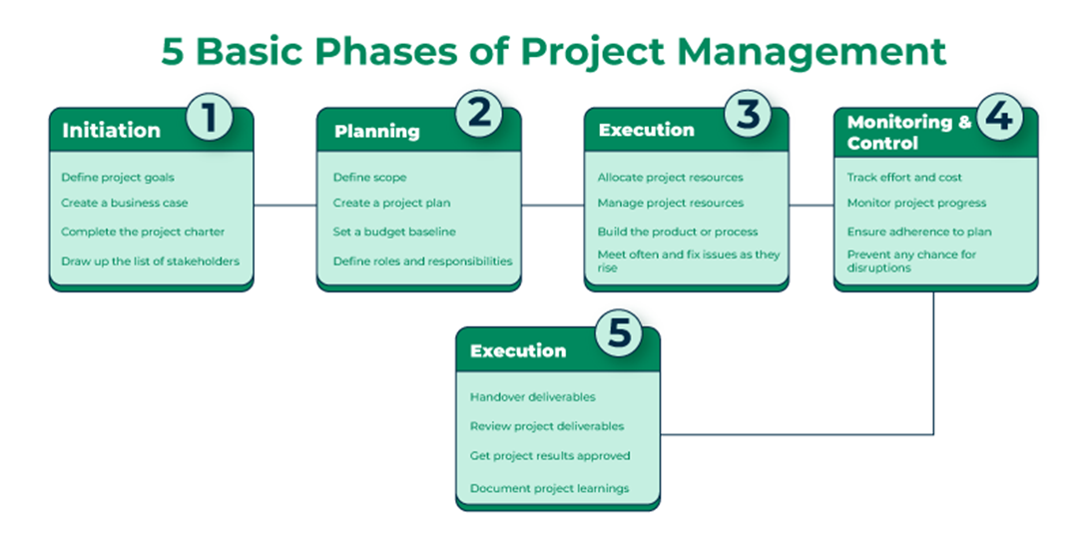

Figure-1

The project outcomes included:

**Project outcomes for the Bus reservation system may include:**

* **Improved User Experience: Passengers benefit from a more convenient and reliable public transportation experience with real-time bus tracking and estimated arrival times, leading to increased satisfaction and loyalty.**
* **Enhanced Efficiency: Bus operators can optimize routes and schedules based on real-time data, reducing delays and improving overall service efficiency.**
* **Increased Transparency: The system promotes transparency by providing passengers with visibility into bus locations, routes, and schedules, fostering trust and confidence in the public transportation system.**
* **Data-Driven Decision Making: Administrators can make informed decisions about resource allocation, route planning, and service improvements based on data collected by the system, leading to more efficient operations and better service delivery.**
* **Reduced Wait Times: Passengers can plan their journeys more effectively and minimize wait times at bus stops by accessing accurate arrival time estimates provided by the system.**
* **Enhanced Safety and Security: Real-time tracking allows for better monitoring of bus movements, which can contribute to enhanced safety and security for passengers and operators alike.**
* **Scalability and Adaptability: The system is designed to be scalable and adaptable to accommodate future growth and changes in transportation infrastructure and technology.**
* **Cost Savings: By optimizing routes and schedules and reducing operational inefficiencies, the system may result in cost savings for transportation agencies and operators.**
* **Positive Impact on the Environment: By encouraging the use of public transportation through improved convenience and reliability, the system may contribute to reduced traffic congestion and environmental pollution.**
* **Feedback Mechanism: The system provides a platform for collecting feedback from passengers, allowing transportation authorities to identify areas for improvement and address concerns proactively.**
* **Overall, the Bus reservation system aims to deliver tangible benefits for passengers, bus operators, and administrators alike, ultimately contributing to the improvement of public transportation services and the quality of urban living.**

Model Description

The Bus reservation system is designed as a model that integrates various components to facilitate real-time tracking and management of bus fleets. Here's a description of its key components:

1. User Interface (UI):
   * The UI provides an intuitive and user-friendly interface for passengers, bus operators, and administrators.
   * Passengers can access the system via web or mobile applications to view bus routes, track bus locations, and receive alerts and notifications.
   * Bus operators and administrators have access to a dashboard interface for managing bus routes, schedules, and monitoring system performance.
2. Backend Services:

* Backend services handle data processing, storage, and communication between different system components.
* Services are responsible for retrieving bus location data from GPS devices installed on buses and updating the database in real-time.
* Additionally, backend services manage user authentication, access control, and data validation to ensure system security and integrity.

1. Database Management System (DBMS):

* The DBMS stores and manages bus-related data, including bus routes, schedules, locations, and historical information.
* Structured Query Language (SQL) databases such as MySQL or PostgreSQL are commonly used to store relational data efficiently.

1. Real-time reservation System:

* The real-time reservation system utilizes GPS or other location tracking technologies installed on buses to determine their current locations.
* Location data is transmitted to the backend server at regular intervals, enabling real-time tracking of bus movements.

1. Route Planning and Optimization:

* Route planning and optimization algorithms are used to optimize bus routes and schedules based on factors such as passenger demand, traffic conditions, and operational constraints.
* These algorithms help improve service efficiency, reduce delays, and minimize operational costs.

1. Alerts and Notifications:

* The system sends alerts and notifications to passengers regarding bus delays, route changes, or other relevant information.
* Notifications can be delivered via SMS, email, or push notifications through the mobile application.

1. Integration with External Systems:

* The system may integrate with external systems, such as mapping services for displaying bus routes and locations on the user interface.
* Integration with third-party APIs allows for additional features, such as weather updates, traffic information, and public transit data.

1. Scalability and Reliability:

* The system is designed to be scalable and reliable, capable of handling large volumes of data and supporting a growing number of users.
* Scalability is achieved through distributed architecture and load balancing techniques, ensuring optimal performance during peak usage periods.
* Overall, the Bus reservation system combines frontend user interfaces, backend services, real-time tracking technology, and optimization algorithms to provide an efficient and reliable solution for tracking and managing bus fleets in real

Implementation Approach:

The implementation approach for a Bus reservation system involves several steps to ensure a successful development process. Here's a structured approach to implementing such a system:

1. Requirement Analysis:

* Gather requirements from stakeholders, including passengers, bus operators, and administrators.
* Define the functional and non-functional requirements of the system, considering factors such as real-time tracking, user authentication, route optimization, and scalability.

1. Technology Stack Selection:

* Choose appropriate technologies for frontend development (web or mobile), backend development, and database management based on project requirements and team expertise.
* Consider frameworks, programming languages, and third-party APIs that can streamline development and provide necessary functionality.

1. System Architecture Design:

* Design the overall architecture of the system, considering factors such as scalability, maintainability, and performance.
* Define the structure of frontend components, backend services, and database interactions.
* Determine communication protocols and data formats for real-time tracking and data exchange.

1. Database Design:

* Design the database schema to store bus-related data, including bus routes, schedules, locations, and historical information.
* Choose an appropriate database management system (e.g., MySQL, PostgreSQL) and define tables, relationships, and indices.

1. Backend Development:

* Develop backend services and APIs for handling user authentication, data retrieval, and business logic.
* Implement real-time tracking functionality using GPS data or other location tracking technologies.
* Integrate with external services or APIs for additional features such as mapping and weather updates.

1. Frontend Development:

* Develop user interfaces for passengers, bus operators, and administrators using web technologies (HTML, CSS, JavaScript) or mobile app frameworks (React Native, Flutter).
* Implement features such as real-time bus tracking, route planning, and user authentication.
* Ensure responsive design for compatibility with different devices and screen sizes.

1. Testing:

* Conduct unit tests for individual components to ensure functionality and reliability.
* Perform integration tests to verify interactions between frontend and backend components.
* Test the system under various scenarios, including peak usage, network disruptions, and edge cases.

1. Deployment:

* Deploy the system to a production environment, such as a cloud platform (AWS, Google Cloud, Azure) or a dedicated server.
* Configure monitoring and logging to track system performance, detect errors, and ensure uptime.
* Implement security measures such as encryption, authentication, and authorization to protect user data and system integrity.

1. User Training and Documentation:

* Provide user training materials or tutorials to help users navigate the system effectively.
* Document system architecture, APIs, deployment procedures, and troubleshooting guidelines for future reference.

1. Maintenance and Support:

* Provide ongoing maintenance and support to address bugs, implement feature enhancements, and respond to user feedback.
* Monitor system performance and scalability, and make necessary adjustments as traffic and usage patterns evolve.

By following this implementation approach, you can develop a robust and efficient Bus reservation system that meets the needs of passengers, bus operators, and administrators while ensuring scalability, reliability, and usability Benefits:

* **Flexibility**: Ability to respond quickly to changing requirements and market dynamics.
* **Stakeholder Engagement**: Increased collaboration and alignment with stakeholder need and expectations.
* **Faster Time-to-Market**: Delivery of valuable functionality in shorter development cycles.
* **Quality Assurance**: Continuous testing and feedback loops ensure a high-quality product.
* **Adaptability**: Ability to adapt to emerging trends and technologies throughout the project lifecycle.

**Technology Used**

The technology stack used for implementing a Bus reservation system can vary depending on specific requirements, preferences, and expertise of the development team. Here's a generalized overview of the technologies commonly employed in each layer of the system:

1. **Frontend Technologies:**

* Web Application:
* HTML5: For structuring the content of web pages.
* CSS3: For styling and formatting the user interface elements.
* JavaScript: For client-side scripting and interactivity.
* Frameworks like React.js, Angular, or Vue.js for building dynamic and responsive web interfaces.
* Mobile Application:
* For Android: Java or Kotlin for native Android development, or frameworks like React Native or Flutter for cross-platform development.
* For iOS: Swift or Objective-C for native iOS development, or React Native or Flutter for cross-platform development.

1. Backend Technologies:

* Programming Languages:
* Python, Ruby, Java, or Node.js for backend logic and server-side scripting.
* Frameworks/Platforms:
* Django, Flask, Ruby on Rails, Spring Boot, or Express.js for building RESTful APIs and handling backend operations.
* Real-time Communication:
* Web Sockets or libraries like Socket.IO for real-time communication between the server and clients.

1. Database Technologies:
   * Relational Databases:

* MySQL, PostgreSQL, or SQLite for structured data storage and management.
* NoSQL Databases (if needed):
* MongoDB or Cassandra for storing unstructured or semi-structured data.
* Real-time Tracking and Geolocation:
* GPS Technology: Utilizing GPS hardware installed on buses to track their real-time locations.
* Geolocation APIs: Integrating with APIs provided by mapping services like Google Maps, Mapbox , or OpenStreetMap for geocoding, reverse geocoding, and displaying maps.
* Location-based Services (LBS): Implementing algorithms for calculating distances, routes, and estimated arrival times based on geographic data.

1. Deployment and Infrastructure:

* Cloud Platforms: Amazon Web Services (AWS), Google Cloud Platform (GCP), Microsoft Azure, or Heroku for scalable and reliable hosting.
* Containerization: Docker for packaging the application and its dependencies into containers for easy deployment and scalability.
* Orchestration: Kubernetes for automating deployment, scaling, and management of containerized applications.

1. Additional Tools and Libraries:

* Version Control: Git for managing source code and collaboration among team members.
* Testing Frameworks: Jest, PyTest, or JUnit for unit testing and integration testing.
* Monitoring and Logging: Tools like Prometheus, Grafana, or ELK Stack for monitoring system performance, logging, and error tracking.
* By leveraging these technologies effectively, you can build a robust and feature-rich Bus reservation system that meets the needs of passengers, bus operators, and administrators while ensuring scalability, reliability, and usability.

**References Used For lab Project**

When working on a project like a Bus reservation system for software engineering, it's essential to consult a variety of resources to gather information, learn best practices, and make informed decisions. Here are some potential references that could be useful:

1. Textbooks and Academic Papers:

* + "Software Engineering: A Practitioner's Approach" by Roger S. Pressman.
  + "Design Patterns: Elements of Reusable Object-Oriented Software" by Erich Gamma, Richard Helm, Ralph Johnson, and John
  + Various academic papers on topics like real-time tracking, route optimization algorithms, and user interface design

2. Online Documentation and Tutorials:

* + Official documentation for technologies and frameworks being used in the project, such as React.js, Django, Node.js, or MongoDB.
  + Tutorials and guides on building similar systems available on platforms like Medium, YouTube, or developer forums like Stack Overflow.

3. Case Studies and Industry Reports:

* + Case studies from companies or organizations that have implemented similar bus tracking or public transportation systems.
  + Industry reports or whitepapers on trends and best practices in public transportation management and software development.

4. API Documentation and Developer Guides:

* + Documentation for APIs and services being used in the project, such as Google Maps API, GPS tracking APIs, or weather data APIs.
  + Developer guides and reference materials provided by hardware manufacturers or service providers for GPS tracking devices, sensors, or other relevant technologies.

5. Open Source Projects and Code Repositories:

* + GitHub repositories or open-source projects that implement features or functionalities similar to those needed for the Bus reservation system.
  + Studying code samples and project structures from open-source projects can provide valuable insights and serve as a reference for implementation.

6. Professional Networks and Conferences:

* + Engaging with professionals in the field of software engineering, transportation management, or related industries through networking events, conferences, or online forums.
  + Attending conferences or workshops focused on software engineering, public transportation, or technology innovation for insights and inspiration.

7. Mentors and Advisors:

* + Seeking guidance and advice from mentors, professors, or industry experts who have experience in software engineering, system development, or public transportation management.

8. Official Documentation and Guidelines:

* + Government or regulatory agency websites that provide official documentation, guidelines, and standards for public transportation systems and software development in the relevant jurisdiction.
* By leveraging these diverse resources, you can gather valuable information, stay informed about industry trends, and make informed decisions throughout the development process of your Bus reservation system.

# This is a broad overview of the technologies commonly used in building Bus reservation systems. The specific technology choices may vary based on project requirements, budget constraints, and the preferences of the development team.

